**Usability Report**

**BottomLineTelecommunications**

**INF 132 Project Assignment #2**

Monday 6:00 P.M Discussion - Group 7

Alonso De La Torre Vega

Matthew Morales

Phillip Nguyen

Jason Hing Lun Tam

Juwan Michael De Jesus

# 

# Table of Contents

**Table of Contents** **1**

**Executive Summary:** **2**

**Introduction:** **3**

**Description of Study Objectives:** **4**

**Description of Target Population:** **5**

**Description of Methods:** **6**

**Findings** **7**

**Personas:** **12**

**Appendix:** **15**

Interview Protocol: 15

Survey Questions 18

**Informed Consent Documents:** **25**

Interview Log: 27

Chart showing a summary survey participants: 28

# **Executive Summary:**

As a thriving e-commerce website that has been in the electronics industry for a while now, the redesign team for BottomLineTelecommunications believes the services provided to the website will attract future customers and satisfy current customers. To further enhance the user experience of the website, the main focus is based on the interaction between the user and the system; concentration is put into the flow of interaction going both directions, from user to system and from system to user, and the team collectively decides how each entity can better interact with one another. The investigation further continues by analyzing users’ shopping patterns for electronics, as well as understanding the system’s categorization of information and how these concepts influence consumer decisions on their preferences.

In order to understand the interaction between users and the system, it was necessary to recognize the customer audience using the website. The predefined hypothesis of who the users of the website could be were: males ages 20 and up. Findings from the development team’s research suggests much of the hypothesis was true, where many of the users were males between the age 20-40. The main method used to gather data was through interviews. Each person on the team conducted two interviews. As a secondary method of data gathering, a survey was constructed and sent out inquiring about information regarding, online shopping behaviors for electronic items. The interviews consisted of a series of questions designed to probe information about individual shopping habits/behaviors, like/dislikes, what is appealing and what is difficult about shopping online for electronics. The surveys were designed to bring a quantitative perspective to the same goals.

The following sections of this document provide further details regarding these findings. A quick summary of said findings suggests that more people prefer shopping in-store in general however, this is not the case for electronics, where online shopping is more preferred. Of those who participated the majority were male. Satisfaction rates from online shopping compared to in store shopping were much higher when it came to shopping for electronics. The collected data also suggests individuals prefer to filter search results by key aspects to find their product. From these high level findings, three personas were constructed: the online electronic shopper, the careful online shopper, and the traditional in-store shopper to guide the redesign efforts.

# **Introduction:**

Started in 1991 as a systems design and consulting firm, BottomLineTelecommunications (BLT) is an e-commerce website providing its customers with over 300,000 products and solutions from major manufacturers all over the world. This product service is similar to those of Amazon and eBay where most customers purchase products online and have those products shipped directly to them without seeing the product in-person. Upon viewing BLT’s website, shopblt.com, it is easy to discern the many design choices (or lack thereof) that results in a difficult user interface to operate; these choices mainly affect the product search and purchasing process.

The purpose of this project is to gain an understanding as to how this interface could be improved through five main objectives, which include: learning how customers search and select electronics, discovering pain points and pleasures when they’re searching for electronics, analyzing what customers do to seek help for understanding electronics on the website, noting customer preferences for browsing within categories, and understanding what information customers value when searching for electronics. Through analysis of this data, BLT’s website could be improved to deliver a superior user experience to its customers around the world.

# **Description of Study Objectives:**

1. Understand how customers select and order electronics.
   1. This is an objective used to gain a better understanding of processes customers deploy when actively shopping for electronic items. By understanding the underlying procedures for product selection, better design interaction will fall in line with real consumer behaviors.
2. Discover pain points, and pleasures, within search patterns for electronic products online.
   1. Pain points are a necessary consideration when gathering data for analyzing user search processes and applying them to a redesign of an existing web service. Exploring the aspects that prove to create difficulties for users will help with gaining a better understanding of key elements that make for a better user experience. Furthermore, it will also help to know what keeps users happy to further implement those elements and seek to adapt the pain points with the customer’s pleasures.
3. Discover what customers do to seek help, in terms of understanding the information about electronics online.
   1. Customers cannot always find the right information about a product they wish to purchase. This will lead some customers to searching for relevant product information via external sources. This objective aims to find out how much of a problem this is for consumers who want to purchase electronic products and how this problem (if it exists) could be alleviated.
4. Discover preferences for browsing within particular categories (electronics).
   1. This objective seeks to find common preferences among consumers for product discovery when browsing among electronic items online. Preferences vary based on the type of service and product a consumer may be using, however there may be common foundational themes among the variance.
5. Understand what product information is valuable to customers when they are searching for electronics.
   1. Information is key when a consumer is trying to make an informed purchase for any type of product, especially electronics. This objective aims to find what kind of information is most valuable to consumers when searching and shopping for electronics. Relevant information ranges from product price, description, and details to seller credibility, product reviews, and estimated shipping time.

# 

# **Description of Target Population:**

A detailed analysis shows that BLT’s target population consists of mostly males ranging from ages 20-40, from middle to upper class. These buyers are mainly from the United States, although some buyers are international. Most of this target population are people who prefer to shop online and do not have to visit a physical store before making a purchase. Thusly, competitors such as Fry’s Electronics and Best Buy will not prove to be as influential as direct online competitors such as Newegg and Amazon. Results from collected data have shown that of the individuals surveyed and interviewed, most participants have a clear understanding and idea of what product they want to purchase. It is expected that the target population will not seek personal assistance when identifying and purchasing their desired product, compared to those who would who shop in store. The data also shows that of the participants in the interviews and surveys, the majority of them value information like: product reviews, pricing, product visibility, ease of payment, and seller credibility. The results also indicate that many of the participants are comfortable with shopping online, in that they do not have difficulty finding the products they want, or the information they need.

Using this information, a comparison was made between the user base of BLT to that of the information from the interview and survey participants. Both usually have a particular product in mind when shopping on the website (for example, graphics cards). Information from the participants regarding technological skills such as, familiarity with interaction layouts, where to find information, and product details (when it comes to electronics) are also in line with BLT’s user base, making it more of a niche service than its competitors like Amazon. The conducted survey results suggest price was among the most important information to the consumer, leading more consumers to seek less expensive products first. Two of the most appealing advantages of BLT’s services for consumers are their lower prices and quality customer service. The transparency of BLT is another reason consumers would flock to their website, as the company provides a plethora of industry and product information. Of the information and services that are important to the participants, product visibility and ease of payment are not reflected by BLT’s service. BLT appeals to a user base similar to the participant pool, given most of the products are provided by big name manufacturers and the fact that BLT advertises its high credibility, which falls under seller credibility and trustworthiness.

# **Description of Methods:**

Keeping the objectives in mind, the interview and survey questions were developed in collaboration with each other. For the interview questions, each team member selected two interviewees who were gauged to be fit to answer the questions. The interviews ranged from twelve minutes to forty-five minutes, averaging out to an intended goal of around a half-hour. For the survey questions, Google Forms was used as a means to administer the questions. To recruit participants, each team member shared the survey with friends through social media and messaging, and accumulated around sixty survey responses soon after. Data was observed using Google Spreadsheets and helped with making several charts detailing the observations; charted data included gender percentages, difficulty finding products, external sources used for product information, shopping preferences, customer satisfaction after online purchases, and favorite browsing method.

Both interview and survey questions were constructed to be straightforward and easy-to-comprehend. An example of one of the simple survey questions is shown below (Fig.. A), which shows a chart of the participants’ preferred vendors when it came to online shopping.

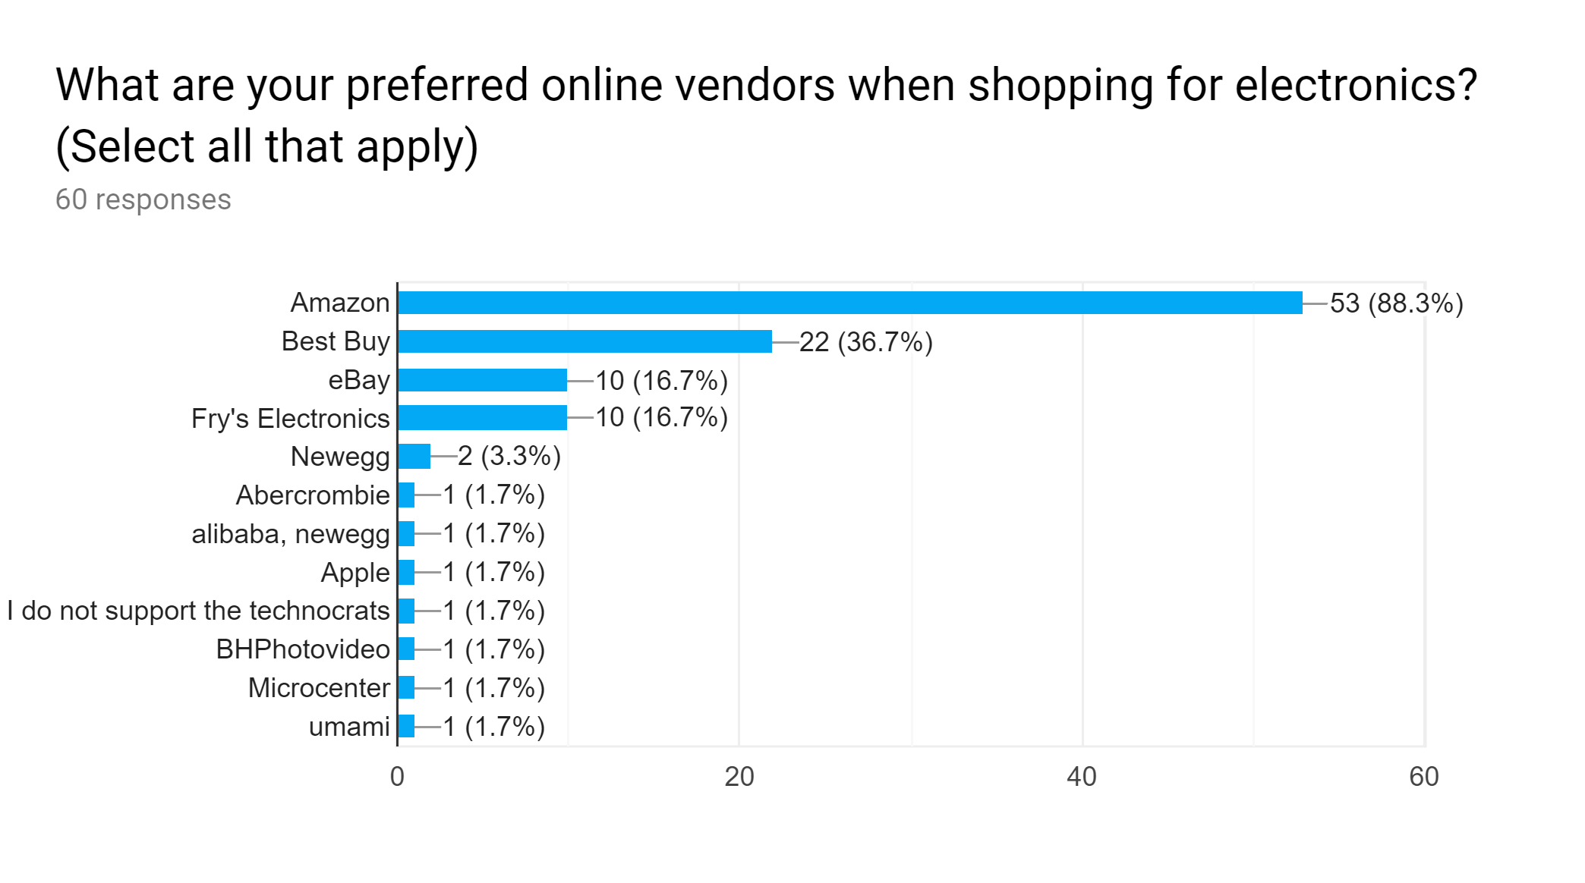

**Figure A: (Survey) Chart displaying Survey Question Data**

# Findings

Ten interviews were conducted in all (two interviews each person) and sixty survey responses were completed and received. On February 1st, an affinity diagram based off the interview responses was constructed by the team to draw conclusions from what the respondents felt was most important about the interview objectives (Fig. B, C).

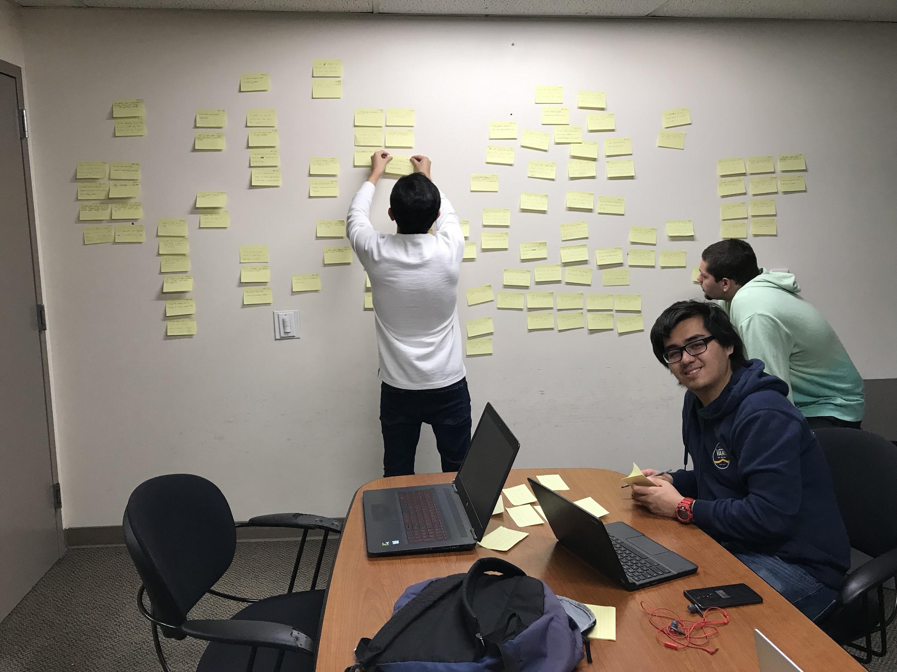

**Figure B: Juwan, Phil, and Matt creating the diagram alongside Alonso and Jason (not pictured).**

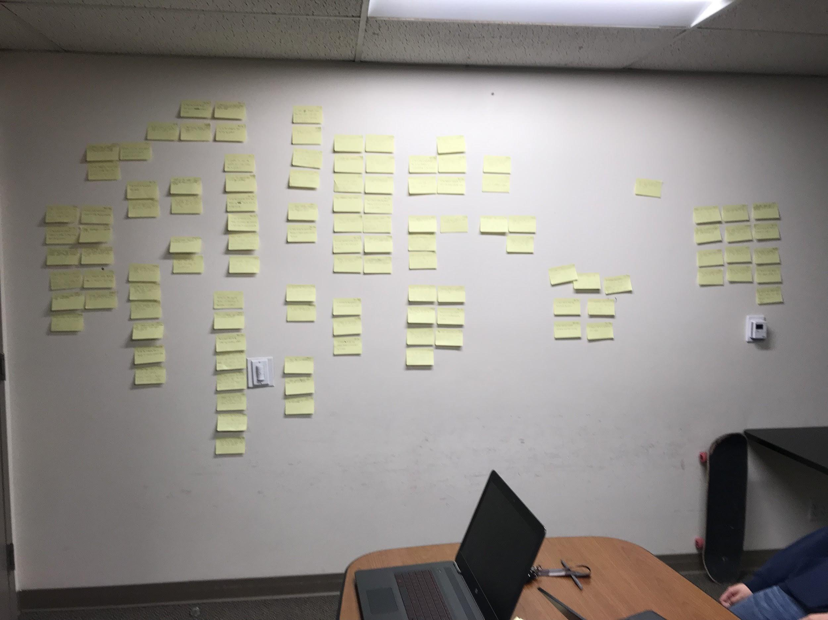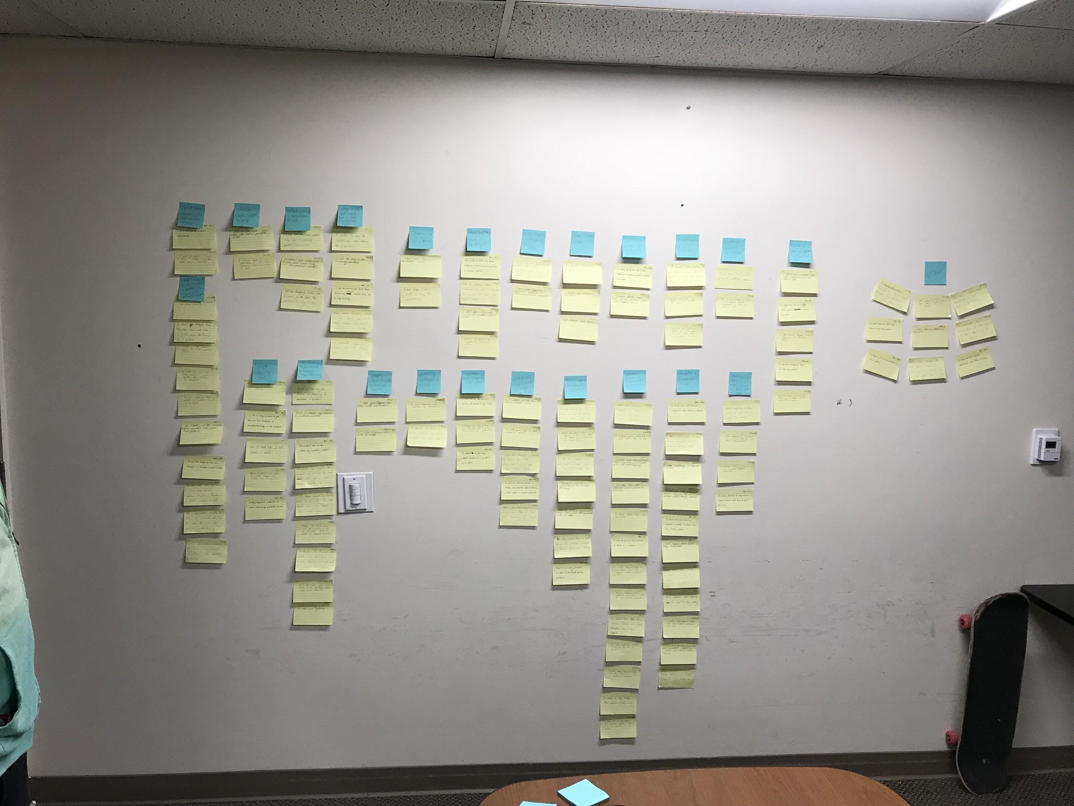

**Figure C: A before and after shot of the affinity diagram**

It was observed from the findings that the majority of survey respondents were male, sitting at 61.7%, while female participation was at 33.3%. Others genders included: one “attack helicopter”; one “Flying Spaghetti Monster, w/ extra sauce”; and one who did prefer not to state their gender. The youngest survey participant was born in the year 2000 while the oldest participant was born in the year 1975. Out of the surveyees, 10 had completed high school, 24 had completed 1-2 years of college, and 26 had completed 3+ years of college.

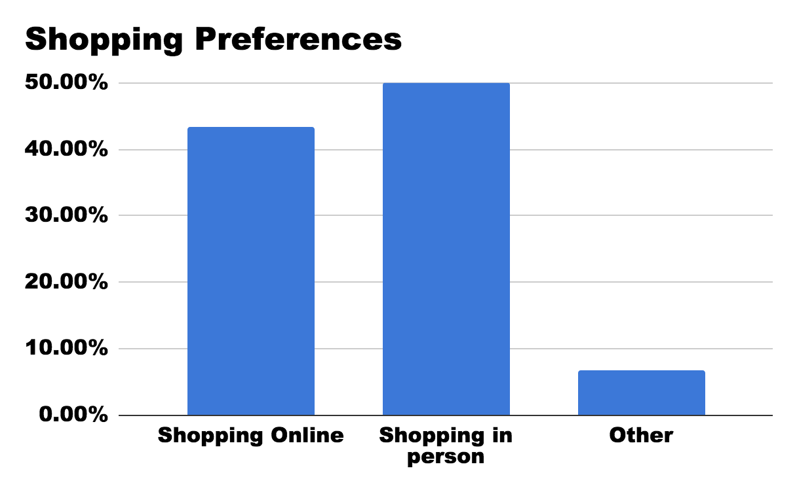

**Figure D: (Survey) Which of these shopping methods do you prefer more?**

One thing noticed during the interview process was the emphasis on the convenience factor of shopping online compared to in-store, which lead to the notion that online shopping was the main bias for the surveyees as well. However, the survey shows that half of the respondents preferred to shop in-person compared to the 43% of people who preferred shopping online (Fig. D). The other 7% had many different answers ranging from not shopping for themselves at all to having some combination of both for different reasons.

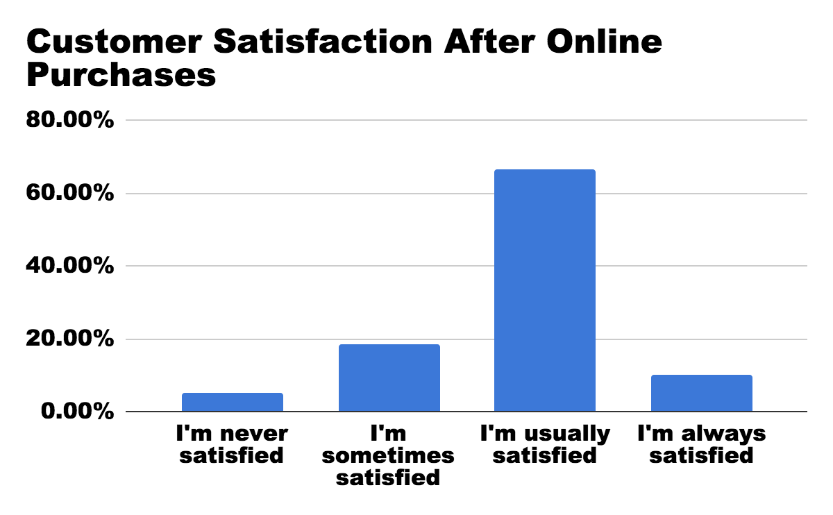

**Figure E: (Survey) How often are you satisfied with your online shopping experience for electronics?**

When looking at the survey data regarding customer satisfaction, around 76% of respondents are usually satisfied with their purchases online (Fig. E). A majority of the respondents shopped at big companies online stores, such as Amazon, Ebay, and Best Buy, which are known to be fast and reliable at providing the products that people would need. On top of all of this, about 70% of people are comfortable with shopping online, meaning most of the respondents find no trouble in purchasing products from online retail sites.

The problem that seems to be deterring some of the respondents from preferring online shopping is the frustration that comes with the process of online shopping. While most aspects are intuitive to some people, there are a lot of minor details that can bother and even deter the online retail sites user bases. About 63% of the respondents seemed to have some sort of difficulty when trying to find the products they needed from an online store; some refer to it as one of the negative sides of online shopping for a casual user (Fig. F).

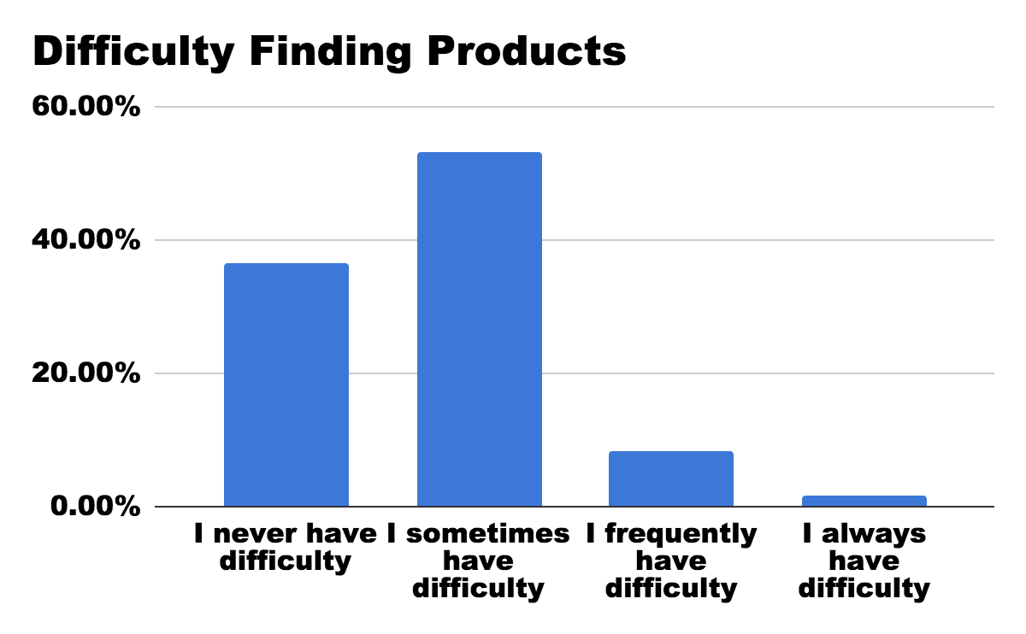

**Figure F: (Survey) Which response most represents you when finding products you want to buy?**

Drawing from the survey and the interviews results, no two people seemed to have the same difficulties when it came to searching for products. After the respondents were finally able to find the product they were looking for, about 70% of them said they spend at least an hour doing research about the product they are interested in. From this, it can be assumed that product research is time consuming for a consumer and, depending on the results, can make or break a consumer purchase. Some of the most popular sources that were used in product research were Google, YouTube, and Reddit (Fig. G). More often than not, participants said they used more than one of these methods to research and compare product information. Some of the respondents even preferred looking for negative reviews in an attempt to weigh pros and cons.

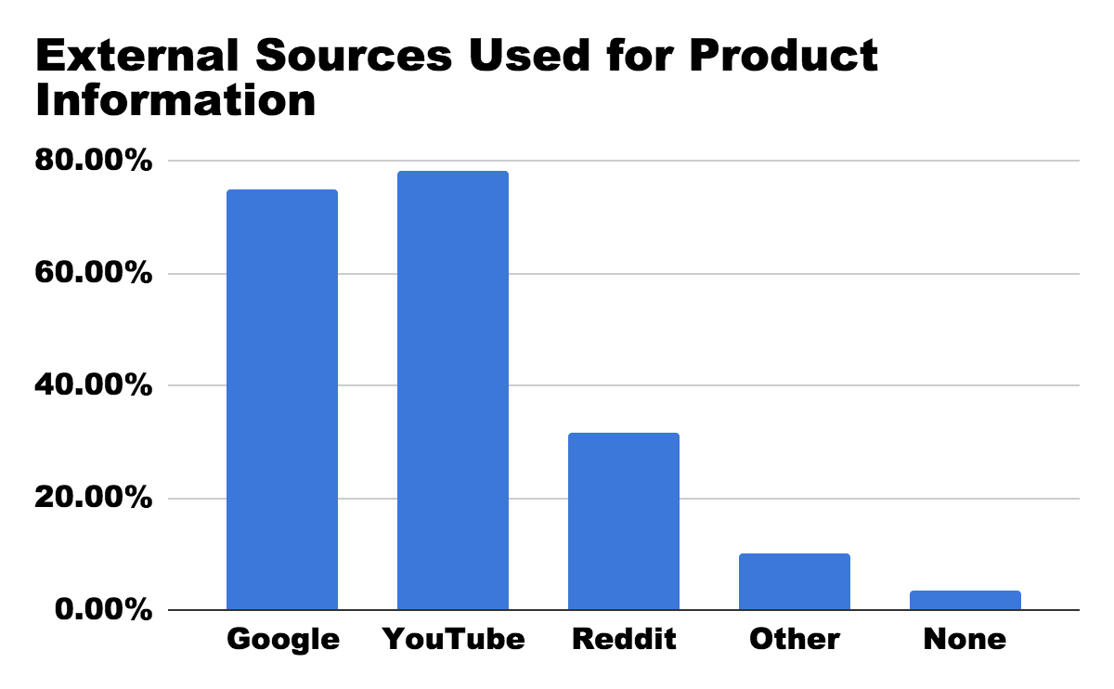

**Figure G: (Survey) What sources do you use for finding information about the products you want to buy?**

Customer reviews were also a big factor when it came to product comparison and the purchasing decision. About 90% of the respondents believed that customer reviews were important and needed to be taken into consideration when purchasing a product. If a product lacked customer reviews, the surveyees found it easy to skip over it for fear of a risky buy.

The last important thing the survey and interviews looked at was the users preferred method of browsing products when already on a specific website. The data for this one sees search bar as the most popular browsing method for the respondents (Fig. H). However, there is only around a 20% difference compared to the other options, meaning that all the users tend to have their own preferences when it comes to browsing.

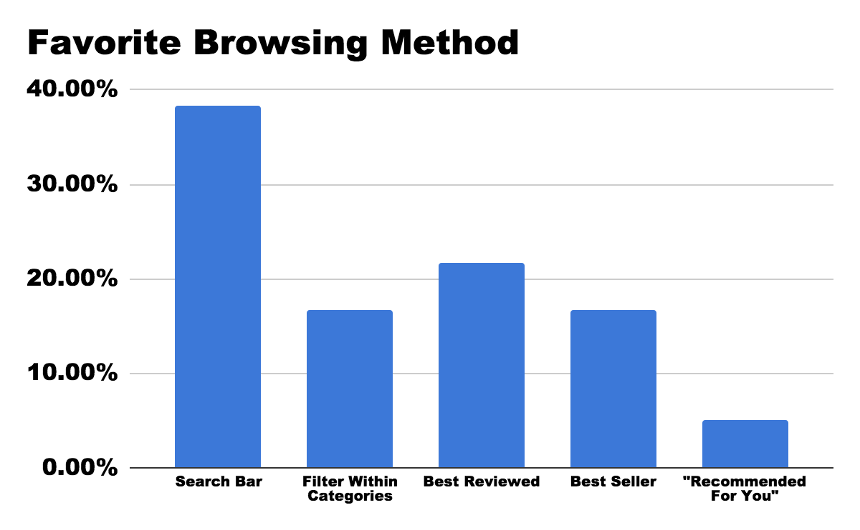

**Figure H: (Survey) When browsing for electronics, which of the following is your favorite method?**

From this data, a conclusion can be made that a good search bar formula would be beneficial towards a more user-friendly consumer products site. Whether it be for convenience or organization, all of the participants had different needs and different preferences. From the survey data, potential users seem to like seeing price first and foremost when they first find a product. Next, they seem to want images, and then customer reviews from their consumer products websites. Implementing better ways of showcasing these attributes on a product discovery page or a splash screen could remarkably improve the user experience of shopblt.com, if implemented correctly.

# Personas:

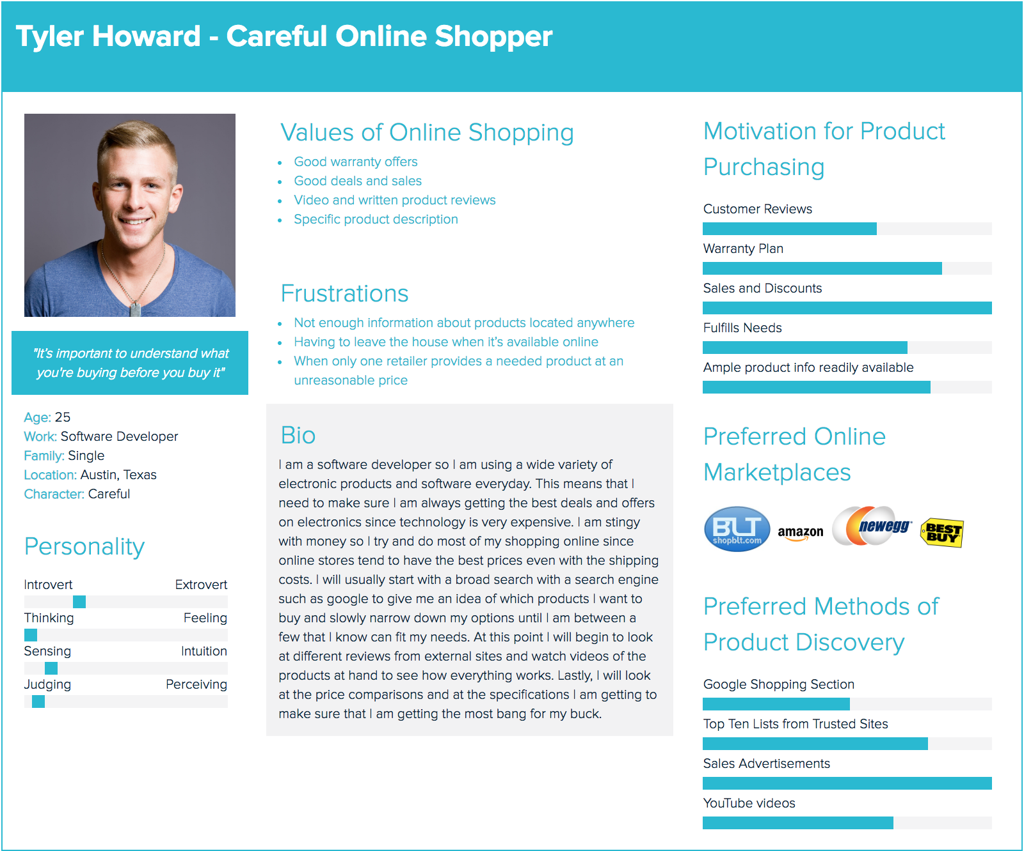

# 

# Appendix:

## Interview Protocol:

Ice Breaker/Intro to interview:

*We wanted to be friendly with our interviewees and sort of ease them into our interview rather than just start it abruptly. Below is our script that we loosely used to start things off.*

Hello, what’s your name? __________. Nice to meet you, my name is _________. How are you doing today? __________, that’s good to hear. So today I’ve brought you in to talk about shopping for electronics. I know many people tend to have different habits when it comes to that. So to start off, how about you tell me about the last time you went shopping…….*then go to first question.*

---------------------------------------------------------------------------------------------------------------------

* How often have you gone shopping in the last month?
* Where is your favorite place to shop for electronics?
* When you shop for electronics do you have a solid idea or understanding of what you want?
* How often have you gone shopping for electronics in the last month?
* When was the last time you bought something electronic?
  + Is there anything particularly difficult about shopping for electronics?
  + Did you buy that online or in a store?
    - Why that choice? (*What is it about shopping online or in person that makes you prefer that method?)*
* When shopping online:
  + What is your preferred method of searching for a product?
  + How do you decide whether or not to purchase a product?

Understand how customers select and order electronics

* What do you enjoy about shopping online?
* What do you dislike about shopping online?
* What helps you make a choice?

Discover what customers do to seek help, in terms of understanding the electronics on the website

* If you are unable to find a product, what do you do?
* (Propose a scenario with a familiar method of online shopping, Amazon). If you are trying to find additional details regarding product information where do you look first?

Discover pain points (and things they like) within search patterns for electronic products

* Do you have difficulties when shopping online?
  + What is the particularly difficult when looking for electronic products?
* Is there anything that makes shopping online easier for you?
  + (If “Yes”) What things make shopping online easier?
  + (If “No”) What would you like to see to make your online shopping experience better?

Discover preferences for browsing within particular categories (electronics)

* What is your go-to method of product discovery when you search for products. (Ex: search bar, categories, front page browse)

Understand what product information customers value when searching for electronics

* When choosing a product, what information is valuable to you?
* What information do you look for when comparing products?

## Survey Questions

**Disclaimer:**

We are conducting a study of customer behavior habits and preferences with regards to shopping for electronic items online. The purpose of this study is to gather relevant participant data, which will be applied to the redesign of the online web service BottomLineTelecommunications (BLT, shopblt.com). This study is not a measurement or performance nor will your answered provided by compared to an objective standard. This study is being conducted as part of a course at the University of California, Irvine, entitled, “Informatics 132: Project in Human Computer Interaction.” As such, this is also a training opportunity for our group as students of information science. By participating in this survey you agree to allow us to use the data you give us, along with the information we collect from other participants, to better design BLT. To ensure confidentiality, we will not associate your name with your data.

**Participant Demographics:**

* What is your gender? _______
* What year were you born?: __________
* What’s your highest education level?
  + Elementary School
  + Middle School
  + High School
  + 1-2 years of college
  + 3+ years of college

**Understand how customers select and order electronics**

* How often, in the last six months, have you shopped for electronics online?
  + Daily
  + At least once a week
  + At least once a month
  + I never shop for electronics online
* Which of these shopping methods do you prefer more?
  + Shopping online
  + Shopping in person
  + Other: __________
* What are your preferred online vendors when shopping for electronics? (Select all that apply).
  + Amazon
  + Best Buy
  + Fry’s
  + Ebay
  + Other: _______________

**Discover pain points within search patterns for electronic products**

* How comfortable are you with your knowledge and skill-set regarding electronics when you shop for them online?
  + Very uncomfortable
  + Somewhat uncomfortable
  + Somewhat comfortable
  + Very comfortable
* Which response is most representative of you when trying to find the products you want to buy?
  + I never have difficulty
  + I sometimes have difficulty
  + I frequently have difficulty
  + I always have difficulty
* What are some difficulties for you when shopping for electronics online?
  + ________________________________________
  + N/A
* How often do you get frustrated when shopping online for electronics?
  + I never get frustrated
  + I sometimes get frustrated
  + I frequently get frustrated
  + I always get frustrated
* How often are you satisfied with your online shopping experience for electronics?
  + I am never satisfied
  + I am sometimes satisfied
  + I am usually satisfied
  + I am always satisfied
* What can make you feel satisfied when shopping for electronics online?
  + ________________________________________

**Discover what customers do to seek help, in terms of understanding the electronics on the website**

* How much time do you research/learn about a product before you're about to purchase it?
  + 0-30 min
  + 31-60 min
  + 60-120 min
  + > 2 hours
  + Other: ________________________________________
* How often do you find product descriptions useful when trying to figure out if the product is the right one for you?
  + I never find them useful
  + I hardly ever find them useful
  + I sometimes find them useful
  + I always find them useful
* What external sources (ex: google, reddit, etc) do you use for finding information about the products you want to buy?
  + Google
  + Reddit
  + YouTube
  + Other: _________________________
  + I don’t use external sources
* When do you find it necessary to seek out information from external sources? (Check all that apply).
  + The product has no image
  + The product has no customer reviews
  + Need additional information about the product
  + Want to compare price of product on another site
  + Other: ____________________________

**Discover preferences for browsing within particular categories (electronics)**

* When browsing for electronics, which of the following is your favorite method to use?
  + Search Bar
  + Filter Within Categories
  + Best Reviewed
  + Best Seller
  + “Recommended For You”
  + Other: ________________________
* Why do you prefer to use the aforementioned method?
  + __________________________________________________________

__________________________________________________________

* How likely are you to look at the related electronics after you have bought something?
  + Not very likely
  + Somewhat likely
  + Very likely
  + Extremely likely

**Understand what product information customers value when searching for electronics.**

* Which product information aspects do you think are necessary when shopping for electronics? (Check all that apply).
  + Shipping cost
  + Time to ship
  + Customer reviews
  + Price
  + Product availability
  + Product images
  + Product specifications (Brand, dimensions, color, compatibility, etc)
  + Trustworthy retailer
  + Other: __________________________________________________________
* Why do you prefer to use the above method?
  + __________________________________________________________ ___________________________________________________________
* Which do you prefer to see right away when searching for an item? (Choose one).
  + Shipping cost
  + Time to ship
  + Customer reviews
  + Price
  + Product availability
  + Product images
  + Product specifications (Brand, dimensions, color, compatibility, etc)
  + Trustworthy retailer
  + Other: __________________________________________________________
* When shopping for electronics online, how often do you read customer reviews?
  + I never read customer reviews
  + I almost never read customer reviews
  + I sometimes read customer reviews
  + I always read customer reviews
* How important are customer reviews when looking for a product?
  + Not very important
  + Somewhat not important
  + Somewhat important
  + Very important
* How much do customer reviews affect your final decision when buying a product?
  + Not very much
  + Somewhat not much
  + Somewhat much
  + Very much

# Informed Consent Documents:

**Statement of Informed Consent**

**Purpose:** We are conducting a study of customer behavior habits and preferences with regards to shopping for electronic items online. The purpose of this study is to gather relevant participant data, which will be applied to the redesign of the online web service BottomLineTelecommunications (BLT, shopblt.com). This study is not a measurement or performance nor will your answered provided by compared to an objective standard. This study is being conducted as part of a course at the University of California, Irvine, entitled, “Informatics 132: Project in Human Computer Interaction.” As such, this is also a training opportunity for our group as students of information science.

**Procedure:** You will be asked to participate in an interview. We will begin by asking you a series of questions that relate to the objectives as follows:

* Understanding how customers select and order electronics,
* Discover what customers do to seek help, in terms of understanding the electronics on the website,
* Discover pain points (and things they like) within search patterns for electronic products,
* Discover preferences for browsing within particular categories (electronics),
* Understand what product information customers value when searching for electronics.

This interview is meant to be a conversation – there are no right or wrong answers. We expect the interview to last approximately 30 minutes. We will take notes about your responses.

**Confidentiality:** We will use the data you give us, along with the information we collect from other participants, to design better technologies. To ensure confidentiality, we will not associate your name with your data.

**Freedom to Withdraw:** Participation in this study is voluntary. You may withdraw from the activity at any time without penalty.  
  
**Contact Information:** If you have any questions or comments, you may contact our voluntary mediator Matthew Morales at: matthdm2@uci.edu, or you may contact the instructor of the course: Matthew Bietz, Ph.D., mbietz@uci.edu.

If you agree to these terms, please indicate your acceptance by signing below:

**Signature: _______________________________________________**

**Printed Name: ____________________________________________**

**Date: ____________________________________________________**

## **Interview Log:**

Participant 1: Male, age 21, avid gamer/4th year Software Engineering student, date: Jan. 30, time: 7:00 pm, duration: 12 minutes, location: interviewer’s apartment, lead interviewer: **Phillip Nguyen.**

Participant 2: Male, age 19, avid gamer/2nd year undeclared student, date: Jan. 30, time: 8:15 pm, duration: 10 minutes, location: interviewer’s apartment, lead interviewer: **Phillip Nguyen.**

Participant 3: Male, age 19, programmer/2nd year Software Engineering student, date: Jan. 30, time: 7:00 pm, duration: 35 minutes, location: Gateway Study Center: study room, lead interviewer: **Alonso De La Torre Vega**

Participant 4: Male, age 24, PC gamer/4th year Software Engineering student, date: Jan. 31, time: 12:30 pm, duration: 45 minutes, location: Gateway Study Center: study room, lead interviewer: **Alonso De La Torre Vega**

Participant 5: Male, age 22, console and PC gamer/4th year Computer Game Science student, date: Jan. 30, time: 7:35 pm, duration: 30 minutes, location: interviewee’s apartment, lead interviewer: **Matthew Morales.**

Participant 6: Female, age 21, online shopper/4th year Psychology student, date: Jan. 30, time: 9:00 pm, duration: 12 minutes, location: interviewer’s apartment, lead interviewer: **Matthew Morales.**

Participant 7: Male, age 22, avid gamer/2nd year Automotive Technology Student, date: Jan. 31, time: 9:15 pm, duration: 30 minutes, location: Discord Voice Chat, lead interviewer: **Juwan Michael De Jesus.**

Participant 8: Female, age 18, Online Shopper/1st year Marine Biology student, date: Feb. 1, time: 3:00 pm, duration: 30 minutes, location: Interviewer's house, lead interviewer: **Juwan Michael De Jesus.**

Participant 9: Female, age 20, Apple Product User/3th year Biology student, date: Jan. 30, time: 3:00 pm, duration: 25 minutes, location: Tastea, lead interviewer: **Jason Hing Lun Tam.**

Participant 10: Male, age 19, online shopper/2nd year Business Administration student, date: Feb. 1, time: 5:00 pm, duration: 10 minutes, location: interviewee’s apartment, lead interviewer: **Jason Hing Lun Tam.**

## Chart showing a summary survey participants:

|  |  |  |  |  |
| --- | --- | --- | --- | --- |
| **Participant #** | **Gender** | **Year Born** | **Highest Level of Education** | **Frequency of online electronic shopping (last 6 months)** |
| 1 | Male | 1998 | High school | At least once a week |
| 2 | Male | 1998 | 1-2 years of college | At least once a week |
| 3 | Female | 1975 | 1-2 years of college | At least once a month |
| 4 | Male | 2000 | High school | Did not shop for electronics online in last 6 months |
| 5 | Female | 1997 | 3+ years of college | At least once a month |
| 6 | Male | 1985 | High school | Daily |
| 7 | Male | 1976 | 1-2 years of college | At least once a month |
| 8 | Male | 1999 | High school | Did not shop for electronics online in last 6 months |
| 9 | Female | 1999 | 1-2 years of college | At least once a month |
| 10 | Female | 2000 | 1-2 years of college | Did not shop for electronics online in last 6 months |
| 11 | Female | 1992 | 3+ years of college | Did not shop for electronics online in last 6 months |
| 12 | Prefer not to say | 1992 | 3+ years of college | Did not shop for electronics online in last 6 months |
| 13 | Female | 1996 | 3+ years of college | Did not shop for electronics online in last 6 months |
| 14 | Flying spaghetti monster, with extra sauce | 1996 | 3+ years of college | At least once a month |
| 15 | Male | 1999 | 1-2 years of college | At least once a month |